**Big Mountain Ski Resort Facility Value Analysis**

**1.0 Introduction**

Big Mountain Resort, a Montana ski resort, has requested data evaluation services to support a possible change to its business model. Big Mountain Resort is considered a premier resort, offering spectacular views of Glacier National Park and Flathead National Forest, with access to 105 trails. This mountain can accommodate skiers of all levels, entertaining about 350,000 guests annually. Specific details summarizing Big Mountain Resort are provided below:

* Guest transportation facilities include 11 lifts, 2 T-bars, and one magic carpet for novice skiers.
* The longest run is named Hellfire and is 3.3 miles in length.
* The base elevation is 4,464 ft, and the summit is 6,817 ft with a vertical drop of 2,353 ft.

Big Mountain Resort recently installed an additional chair lift, increasing its operating costs by $1,540,000 this season. As a premium resort, its pricing strategy has been to charge a premium above the average price of alternatives in its market segment. As a result, the resort has requested services to implement a more data-driven business strategy and provide guidance on selecting a better value for their ticket price. The following sections document the evaluation and development of a pricing model for ski resort tickets.

**2.0 Data Wrangling**

Raw data was provided in .csv format with 330 rows and 27 columns. Big Mountain Resort was represented in the data. After the initial inspection, the primary task appeared to be correcting several missing values—primarily the 'fastEight' and price columns. Additionally, the region column was found to be skewed, as multiple regions represented only California and New York. Summary plots depicting data distribution are provided below.

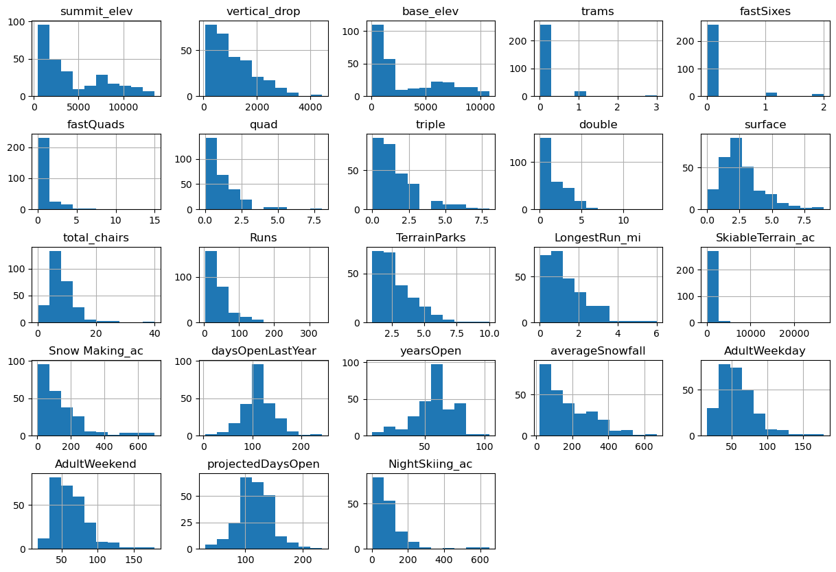

The 'fastEight' column was removed as only one resort reported a value after additional analysis. After further evaluation, rows were released that did not contain both weekday and weekend prices.

**3.0 Exploratory Data Analysis**

Data were explored to identify potential trends or insights. One preliminary finding was that some columns contained state-specific data. With the removal of those columns, a competitive view of each state was achieved. Several trends were identified, but their relationships were interconnected. To disentangle this, a principle components analysis was performed. A series of scatterplots comparing ticket prices to other features are shown below. In this step, it was determined that predicting adult weekend ticket prices was the primary objective.

**4.0 Preprocessing and Machine Learning Model**

Before creating a machine learning model, a portion of the data was randomly removed so the model could be tested once completed. Thirty percent of the original data was removed from a test set. A machine-learning model pipeline was created with the following steps:

1. Missing values were replaced
2. Data was scaled to zero mean and unit variance
3. Trained a linear regression model to fit the data

Missing values were replaced using the SimpleImputer method from the sklearn library. Data was then scaled using the StandardScaler method and fitted to a model using the LinearRegression method. The pipeline was later refined to include the SelectKBest method, which helped identify the correct number of parameters. The graph below shows bots validation and SelectKBest results, indicating the optimal number of parameters is 8.

The pipeline was further refined to replace LindearRegression with a RandomForest method. The final validation of the model showed a $1 variance, which was significantly less than the $19 exhibited under the linear regression method.

**5.0 Modeling**

Final modeling proved that Big Mountain Resort was a premier resort. Appendix A includes graphs detailing a comparison of resort facilities. Following this confirmation, the resort provided potential cost cutting scenarios. These scenarios were:

1. Permanently closing up to 10 of the least used runs. This doesn't impact any other resort statistics.
2. Increase the vertical drop by adding a run to a point 150 feet lower down but requiring the installation of an additional chair lift to bring skiers back up without additional snow-making coverage
3. Same as number 2, but adding 2 acres of snow-making cover
4. Increase the longest run by 0.2 miles to boast 3.5 miles length, requiring additional snow-making coverage of 4 acres

**6.0 Conclusions**

The prepared model was run for each scenario, altering specific parameters to match the resort’s plans.

Scenario 1 – Close up to 10 of the least used runs. The graphs below compare the modeled ticket price versus closing 1 to 10 runs. To summarize, says closing one run makes no difference. Closing 2 and 3 successively reduces support for ticket price and so revenue. If the resort closes 3threeruns, it would have the same impact as closing four o, and increasing the closures to 6 or more leads to a large drop. No increase se in the ticket price was supported under this scenario.

Scenario 2 – Adding an additional run, increasing the vertical drop by 150 feet, and installing an extra chair lift. The model supports increasing ticket prices by $1.99. Over the season, this could be expected to amount to $3474638

Scenario 3 – This scenario repeats the previous one but adds 2 acres of snowmaking.

This scenario increases support for ticket price by $1.99. Over the season, this could be expected to amount to $3474638. This indicates that additional snowmaking has no effect on ticket prices.

Scenario 4 - increasing the longest run by .2 miles and guaranteeing its snow coverage by adding 4 acres of snow-making capability. Modeling this scenario did not support any change in the ticket price.

In conclusion, adding 150 in vertical drop supports a ticket price increase of $1.99 increasing another does snowmaking the price further.

**Appendix A**



